Lab 9

Name of Lab

Ezra Senanu

Partner’s name (if applicable)

19th July 2024

ECEN 299

Table 4 Treble Filter Circuit Frequency Response Calculations.

|  |  |  |
| --- | --- | --- |
|  |  |  |
|  | 1 | 1 |
|  | 1 | 1 |

|  |  |  |
| --- | --- | --- |
|  |  |  |
|  | 0 | 0 |
|  | 0 | 0 |

How does this analysis support the claim that the circuit will act as a treble tone control?

The provided frequency response calculations and their behavior at extreme frequencies indicate that the circuit's primary function is to modify the high-frequency components. The treble filter, being a treble tone control, emphasizes or attenuates high-frequency signals while leaving the low-frequency response largely unchanged. The calculations suggest that the circuit effectively maintains a stable response at both ends of the frequency spectrum, aligning with the characteristic behavior of a treble control, which is to modify treble frequencies while keeping the rest of the audio signal relatively unaffected.

**Objectives**

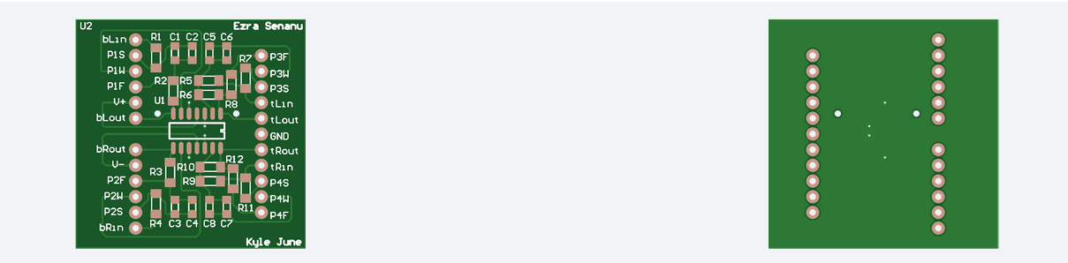

**Preliminary**

Table 1 – Frequency Response Measurements

|  |  |  |  |  |  |  |  |  |
| --- | --- | --- | --- | --- | --- | --- | --- | --- |
|  | **Channel** | $$f(Hz)$$ | **Treble** | | | **Bass** | | |
| $$V_{in}$$ | $$V_{out}$$ | $$A_{dB}$$ | $$V_{in}$$ | $$V_{out}$$ | $$A_{dB}$$ |
| $$α=0$$ | **Left** | $$20Hz$$ | 4.96 | 4.96 | 0 | 4.96 | 1.60 | -9.83 |
| $$200Hz$$ | 4.96 | 4.80 | -0.28 | 5.04 | 1.76 | -9.14 |
| $$2kHz$$ | 5.14v | 2.72 | -5.53 | 5.12 | 4.48 | -1.15 |
| $$20kHz$$ | 5.14v | 1.44 | -11.05 | 5.12 | 5.04 | -0.14 |
| **Right** | $$20Hz$$ | 4.96 | 4.80 | -0.287 | 5.04 | 1.60 | -10 |
| $$200Hz$$ | 5.04 | 2.52 | -6.02 | 5.04 | 1.76 | -9.14 |
| $$2kHz$$ | 5.20 | 1.30 | -12.04 | 5.12 | 4.48 | -1.15 |
| $$20kHz$$ | 5.20 | 1.20 | -12.74 | 5.12 | 5.12 | 0 |
| $$α=1$$ | **Left** | $$20Hz$$ | 4.96 | 4.96 | 0 | 4.96 | 16.2 | 10.3 |
| $$200Hz$$ | 4.96v | 5.12 | 0.27 | 4.96 | 13.8 | 8.88 |
| $$2kHz$$ | 5.04 | 9.68 | 5.67 | 5.12 | 5.68 | 0.91 |
| $$20kHz$$ | 4.88 | 19.4 | 12 | 5.12 | 5.12 | 0 |
| **Right** | $$20Hz$$ | 4.96 | 4.96 | 0 | 5.04 | 16.2 | 10.14 |
| $$200Hz$$ | 4.96 | 5.04 | 0.14 | 4.96 | 13.8 | 8.88 |
| $$2kHz$$ | 4.88 | 9.68 | 5.95 | 5.12 | 5.76 | 1.02 |
| $$20kHz$$ | 4.96 | 19.2 | 11.75 | 5.12 | 5.12 | 0 |

**Conclusion**

The primary goal of this lab was to design, implement, and evaluate the performance of the treble and bass control subcomponents for a stereo amplifier system. This included assembling the PCB designed in Lab 5, soldering the necessary components, and conducting frequency response measurements to ensure the design specifications were met.

The lab successfully demonstrated the design, implementation, and performance evaluation of treble and bass controls for a stereo amplifier system. The measured frequency responses aligned well with the design specifications, confirming the effectiveness of the implemented circuits. This lab provided valuable hands-on experience in circuit assembly and soldering

By following a systematic approach to design, assemble, and test the PCB, the lab objectives were met, and the design specifications were achieved. This experience has solidified the understanding of frequency response analysis, operational amplifier filter design, and practical implementation of audio control circuits.

Paste a copy of lab verification here…

